زمینه های تحقیقاتی اساتید گروه بیوانفورماتیک

نام اساتید | ظرفیت | زمینه های مورد علاقه و تحقیق
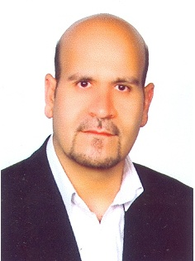  دکتر علی مسعودی نژاد) دانشیار( | ۱ نفر | Computational systems biology  Cancer systems biology  Network biology and Omic’s interaction networks  Brain & biological networks analysis  Cancer and other disease biomarker discovery  Personalized medicine  Drug repositioning & Drug-target networks analysis  Biomarker discovery  Big Data and data integration in systems biology  Bioinformatics and algorithm development  Genome scale analysis of none-coding RNA
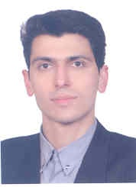  دکتر محمد حسین کریمی جعفری )استادیار( | ۱ نفر | Biomolecular Modeling and Simulation  Structural Bioinformatics  Modeling of Metabolic Networks
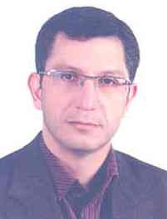  دکتر کاوه کاوسی) استادیار( | ۱ نفر | Bioinformatics & Computational Biology  Complex Biological Systems and Networks  Metagenome & Metatranscriptome Analysis  Machine Learning & Pattern Recognition (application in biology) Uncertainty and Its mathematical basis (application in biology) Data/Information Fusion (application in biology)  Distributed Systems (application in biology)
  دکتر سجاد قرقانی) استادیار( | ۲ نفر | Computational Drug Design  Drug-Target and Drug-Diseases Networks  Machine Learning Methods in Drug Discovery  Systems Pharmacology  Bioinformatics and Computational Biology  Chemoinformatics and Chemogenomics
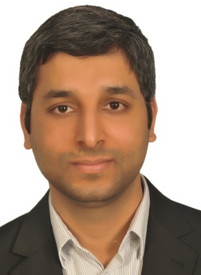  دکتر حسام منتظری) استادیار( | ۱ نفر | Computational biology and biostatistics  Computational cancer biology  Identifying novel cancer genes  Probabilistic graphical models; Bayesian networks  Statistical learning in bioinformatics  Phylogenetic and phylodynamics analysis  More info at: http://lcbb.ut.ac.ir/

